Sophie’s Gift: Thoughts on the Key Document from the International Education Commission
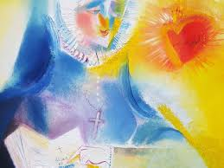
Saint Madeleine Sophie Barat believed that education was not simply about passing on knowledge. Instead, it was a sacred mission to reveal the love of the Heart of Jesus. Her vision was grounded in the belief that every person is deeply loved by God, and that the purpose of education is to awaken that truth within them. This was her gift: an education of the heart, forming the whole person-mind, spirit, and soul.
Stephen B. Whatley 2020
Sophie felt especially called to educate girls in a way that honoured their full potential. Therefore, her approach was rooted in love, relationships, and the nurturing of inner freedom. She believed in forming people who were not only wise and capable, but also compassionate, free, and deeply connected to their purpose in the world.
At the heart of her approach was a deep interior life. Sophie believed that silence, reflection, and prayer were essential, not only for educators, but also for students. She knew that the strength to love and lead comes from within since the inner journey is what allows someone to live authentically and act with courage.
Education, in Sophie’s eyes, was never neutral. Rather, it was a force for transformation at the individual, community and global level. She understood that forming people with critical minds and generous hearts was the most effective way to shape a more just and compassionate society. Her emphasis on relationships, community, and care continues to permeate and guide Sacred Heart education today.
Sophie’s views on education went beyond personal growth and development to a model of education that called people to action. Her focus on love-in-action, rooted in faith, empowers students to face the world with both hope and a sense of responsibility.
Sophie’s gift still speaks to us. It invites us to educate not just for results, but for meaning, dignity, and transformation. Her life and vision encourage us to believe in the goodness within each person. In doing so, through education, we can bring that goodness to life.

Carrying Forward Sophie’s Gift: Reflection for Mission
Saint Madeleine Sophie Barat’s vision of education was a call to action—a mission to form compassionate, reflective, and courageous individuals who work for a more just and loving world. As we reflect on her legacy, consider how you, in your unique role and context, are called to continue this mission of education of the heart.

Reflection Questions

- Who carries the role of educator today?
Is it only teachers, or do parents, mentors, peers, and community leaders also educate in meaningful ways? Can you name examples?

- What does ‘education of the heart’ mean to you?
How can you help others grow not just in knowledge, but in compassion, inner freedom, and purpose?

- Sophie believed silence and reflection nurture inner strength.
How do you create space for interior reflection and discernment in your life or help others to do so?

- Sophie saw education as a force for transformation.
What is one step you can take, big or small, to contribute to a more just, compassionate, and caring community?

- ‘Love-in-action’ was central to Sophie’s vision.
How can you model kindness, listening, and service in your everyday life?

May your reflections inspire you to bring Sophie’s gift to life in the everyday moments and relationships that shape your world.

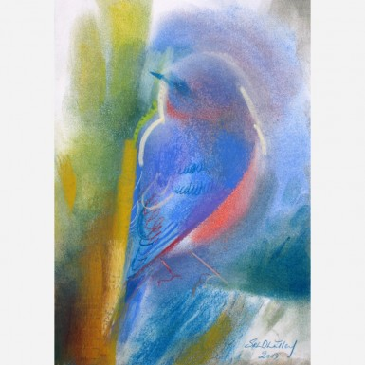
Bluebird of Hope Stephen B. Whatley

