Apostolic Priorities – an attempt at integration
Education – JPIC
Our starting point is the Constitutions of the Society of the Sacred Heart, especially paragraphs *4 and **10 by which the choice has been made around a set of four global Apostolic Priorities in response to the needs of our world – Education, JPIC, Spirituality, Formation. These are core elements which are different facets of the same reality: each priority has its own uniqueness as well as a close relationship with each of the others.
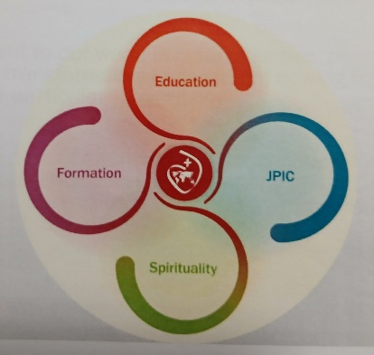
They illuminate, to a greater or lesser degree, our service in the church. These core elements can be imagined as interlocking and dynamic circles that convey a flow of life and energy that can nourish life and mission. They need to function in ways that foster connections and mutual relationships. *** Const. 13
Core values underly all four of the Apostolic Priorities - co-responsibility, collaboration, integration, transformation, subsidiarity
Education includes and embodies the other 3 priorities and is concerned with developing skills, communicating knowledge, and providing experiences all within an environment that is built on good relationships.
In the education process strengthening collaboration with other groups that are equally committed to JPIC is stressed; and humanising the social fabric and thus contributing to global transformation is an important aim.
The quality of relationships is central in the educational process as also in the work of justice and peace; such quality leads to self-knowledge and thus is essential to the work of transformation.
JPIC is a way of life fuelled by Education. Being Artisans of hope in our Blessed and Broken World is strongly emphasised and integrated within the educational process and an outcome of transforming relationships as well as working towards transformation of society – “Education is in itself a work of justice”. (Clare Pratt)
Spirituality and Formation are priorities for which no recent document has been produced but Spirituality permeates each priority and Formation is woven into each. Documents from General Chapters and other international gatherings or groups highlight these priorities as essential in any involvement, ministry or activity. They enable self-knowledge, discernment, and an integration of life and faith

For reflection
How can our commitment to JPIC transform us? What is your experience of transformation?
What further links do you see between the four priorities?
Hope is strongly emphasised in Being Artisans of Hope – what do you see of this theme in the other priorities?

Sources –
Apostolic Priorities International Planning Commission 2023
Sophie’s Gift International Education Commission 2023
Artisans of Hope Society of the Sacred Heart 2019
With thanks also to members of the Charism and Mission Committee

Constitutions of the Society of the Sacred Heart 1982
*4. By our charism, we are consecrated to Glorifying the Heart of Jesus: we answer His call to discover and reveal His love letting our selves be transformed by His Spirit so as to live united and conformed to Him and through our love and service to radiate the very love of His Heart.
**10. We are sent by the Church to communicate the love of the Heart of Jesus. In Him all find their true growth as persons and the way towards reconciliation with one another. This we believe; this we want to proclaim
***13. Conscious that what we do, we do together, and remembering a tradition marked by a love for young people and missionary spirit, we, sent by our superiors, carry out this service of education:
- especially in the work of teaching and formation
- in other activities for human development and the promotion of justice
- in pastoral work and guidance in the faith.
Activities within our own communities contribute to the apostolic effectiveness of the whole group.
Wherever we are sent, whatever our work may be, our lives will be inspired by the love of the Heart of Jesus and the desire of making him known, expressed in
- a concern of the growth of the whole person
- a thirst for working towards justice and peace in the world in response to the cry of the poor
- a passion to proclaim the gospel.

